Parochial Church Council of Whitchurch Canonicorum
Annual Report for 2022
St Candida & Holy Cross; Stanton St Gabriel, Morcombelake; and
St John the Baptist, Fishpond. 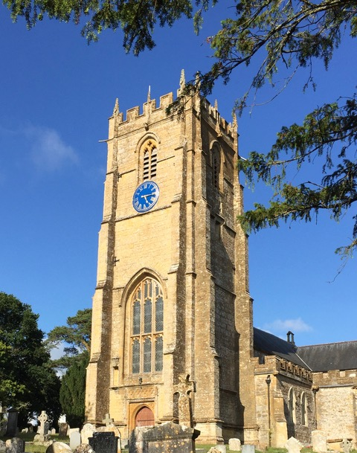
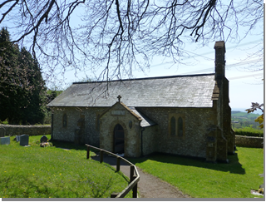
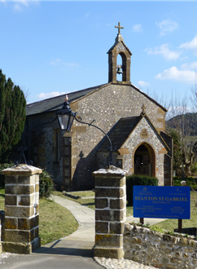

APCM to be held on Thursday 30th May 2023 at 6.30pm in St Candida & Holy Cross Church
www.cathedralofthevale.org

The PCC has the responsibility of co-operating with the Team Rector Revd Chris Martin in promoting in the ecclesiastical parish the whole mission of the Church, pastoral, evangelical, social and ecumenical.
Membership Members of the PCC are either ex-officio or elected by the Annual Parochial Church Meeting (APCM) in accordance with the Church representation rules. During the year the following served as members of the PCC:
Ex Officio: Revd Virginia Luckett (Chair) Ann Bartlett (Churchwarden: Stanton St Gabriel) and Cora Rawlins (Churchwarden: St John the Baptist)
PCC Heather Boyle (Electoral Roll Officer), Una Christopher, Sylvia Creed-Castle, Helen Dobbins, Sue Johnson (Secretary), Felicity Perkin and Ros Woodbridge (Vice-Chair) who are elected members.
PCC officers
Treasurer: Adam Peat
Independent Examiner: Steve Lincoln of P & L Accounts, Bridport
Activities during the year
The PCC has met 5 times this year. Between meetings it operates through the Standing Committee, on which all three churches in the parish are represented. Each individual church has its own designated committee meetings.
Finance
Our financial performance in 2022 was encouraging. Fee income grew from just £823 in 2021 to £3904. Visitor income at St Candida’s from cash donations and sale of publications also grew from £960 to £2,591. Thanks largely to the belated arrival of £5,000 grant from DHCT for the Tower project (which only became payable on practical completion) we were also able to invest £8,000 to finally rebuild our long-term reserves in The Thurston Fund. Full details of the PCC’s financial performance are set out in a separate document, the Annual Accounts 2022.
The Electoral Roll Heather Boyle has continued as our Electoral Roll Officer. She provided a report as required by the Salisbury Diocese confirming that the total number registered on the Electoral Roll at the APCM on 5th May 2022 was 55. This was a decrease of 2 compared with 2021. The numbers for the respective churches are as follows: St Candida and Holy Cross 40 a decrease of 2 elected members; Stanton St Gabriel 8 elected members and St John the Baptist Fishpond 7 elected members. The Churchlands Charitable Trust exists to make small grants to support the extraordinary repairs of St Candida and the Holy Cross and to further the charity objectives of the Church of England in the parish of Whitchurch Canonicorum, St John's Fishpond and Stanton St Gabriel. The trustees met a couple of times during 2022 and are delighted that the kitchen and tower repairs at St Candida are nearly completed. There are plans for a public meeting during 2023 to discuss the activities of the trust going forward.
Over the year the Golden Cap Benefice has continued to produce midweek and Sunday services and Short and Sweet YouTube videos. The Team Council has resumed meetings. Our representatives are Ann Bartlett, Cora Rawlins and Ros Woodbridge. (A report by the Team Vicars is provided as a separate document). Safeguarding The Golden Cap Team Benefice has adopted the Church of England Promoting a Safer Church Safeguarding Policy, which is reviewed each year. Our PCC has adopted this policy and has a Parish Safeguarding Officer (Ros Woodbridge). There is a copy of the policy just inside the porch door and several members of the PCC have attended Safeguarding training and appropriate DBS checks updated. Health & Safety The Health & Safety Policy was reviewed and approved by the PCC. Risk Assessments are continued to be put in place to support our activities. The Quinquennial Inspection is due to be held in 2023 when we will look at new fabric challenges. Both Safeguarding and Health & Safety are regular items on our agendas.
Reports on the activities of each of our three churches are set out below.
St Candida and Holy Cross Ros Woodbridge/Sue Johnson The church continues to have no Churchwarden but is led by a team of Sue Johnson, Ros Woodbridge and Adam Peat with enthusiastic support from Revd Virginia Luckett. Harvest Festival was celebrated with a decorated church and a good number of people in attendance. It was very much a community service and was followed by tea and cakes when we celebrated and gave thanks for the efforts of our Bellringers and Chris Hawkins who supports us with the fabric and projects of our church. There was a collection of food for the Seaside Store in Lyme Regis. This year our Carol Service reverted to our pre-Covid service and was very well supported with a special choir led by Chris Brewer and Nick Brown. We had the usual candlelit service and beautifully decorated church. Wine and mince pies were served afterwards. There was also a special Christmas Short & Sweet, which featured lambs in the story of Jesus’ birth. Our Christmas Eve service was held at 6.00pm with a good congregation. During the year there were four weddings, a renewal of vows, and two christenings. Unfortunately there were six funerals, plus one graveside funeral and two burials of ashes and we offer our condolences to those families. As vergers, Sue Johnson and Ros Woodbridge have had a busy time. Revd Virginia Luckett has introduced Holy Communion with healing services focused on the Shrine. There was also a service for the Lyme Twinning Association.
We have continued to work on the challenges of the fabric of the church as reported in the Quinquennial Report 2018. We are particularly grateful to those who contribute to managing this major task. One of the most challenging issues from the inspection report were the repairs to the tower and clock. The majority of the repairs to the tower are complete and the clock is now sparkling new. It is great to hear the bells ringing once more by our great team of bellringers. The kitchenette obtained its faculty, is in the process of being assembled at Broadoak joinery, and should be completed in early 2023. We are very grateful for the fantastic support of Chris Hawkins in managing this project for us. In the background always giving their support are our cleaners (Holy Dusters), caterers and flower arrangers. The churchyard continues to be maintained by Mark Symonds, who takes great care and pride in its appearance. Our allotment is well supported and organised by Nesta Davies and provides a resource to the community. The AGM of the Friends, of which Sue Johnson is our representative, returned to being held in the Five Bells. The St Candida PCC are very grateful to The Friends of St Candida for the contribution they continue to make to supporting special fabric projects of which the kitchenette has been a very major project. They hosted the annual Alice Dilke concert and a Cantamus concert in the church. The Ride & Stride which raises money for the Dorset Historic Trust and supports the fabric of St Candida and Holy Cross was able to go ahead and was once again very successful. Walkers, cycle riders, runners and tractor drivers raised the grand sum of £405. Our thanks go to Betsy West, Briony Blair and Sam Milburn. An afternoon tea was enjoyed by all participants. Stanton St. Gabriel Church. Ann Bartlett (Churchwarden) Very little has changed since last year’s report. We have two services a month and the size of our congregations stayed the same. We are very fortunate that Derek Dobbs continues to play for us at all our services. Our carol service was well supported and 11 came to our service on Easter day. We had our organ serviced in March, to be sure that it would play well for Betty Fry’s funeral. She had been churchwarden here, until moving to Bridport. The church was full for this occasion. Unfortunately, the organ service let us know that there is asbestos in our blower box and this will be dealt with in due course. St John The Baptist Church. Cora Rawlins (Churchwarden) This has been a much more normal year for us and we are now back to two services a month. The scheme to build a toilet in the Churchyard and a server inside the Church has been forging ahead and we have a very strong communities facilities committee led by Revd Ginny Luckett which meets in the church. We celebrated the Queens platinum jubilee tea party in the churchyard for all the village in June and sadly had a book of remembrance in her honour in the church. Repairs to the church wall still have to be completed and it is hoped this will be done in 2023. We held an art exhibition in the church in August which raised nearly £700 and our Harvest Festival service in September raised £85 for SANE. Our Carol service on Christmas Eve, the first proper one since Covid, was very happy and raised £90 for the NSPCC.
All three churches would like to give a ‘Big Thank You!’ to all those who have helped in 2022 but the more the merrier so, please, if you would like to become more involved in supporting our special churches, please make contact with any one of us. We would love to hear from you and our details are in the Golden Cap Team magazine. We are also very grateful for the marvellous clergy team led by Revd Chris Martin who are always there to support and guide us for which we are very grateful. It was great to welcome Revd Sarah Keen as a curate this year to further enhance our team.

